# Board of Directors

* [Home](https://newroots.org/)
* Board of Directors

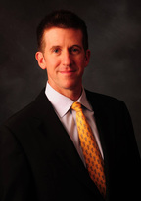

**Chris Chase, Board Chair**

Chris Chase is passionate about New Roots because he has seen firsthand how the lack of healthy alternatives has affected the family of his little brother from Big Brothers/Big Sisters. They live in the poorest part of the city and have few healthy options. The family matriarch receives dialysis three times per week and other family members appear to be on the same track.

Chris is the President, Chief Executive Officer and Chairman of the Board for Discernity, who provides High Speed Internet, DirecTV, Electricity and Natural Gas to Multi-Family Housing, Senior Living and Commercial Properties in an 8 state region. Prior to this role, he was a Regional Director at IBM and Principal Consultant at PricewaterhouseCoopers Consulting where he provided strategic and operational guidance to C-Level Executives for both middle market organizations and some of the largest, most progressive companies in the world. Chris has a Bachelor of Science degree in Computer Science from the University of Kentucky and attended a regional campus of Indiana University where he received his Masters of Business Administration.Chris also volunteers his time as a Parish Council Member, Eucharistic Minister and Coordinator, and Lector at the Church of Epiphany. He is a member of the St. Raphael Conference for St. Vincent DePaul where he also serves food to the poor and homeless at the Helping Hands kitchen.Chris considers his biggest blessing to be his wife of past twelve years and his two daughters.

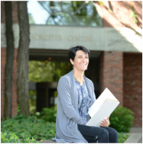

**Sophie Hummer, Vice Chair and Co-Chair Leadership Development Team**

Dr. Sophie Hummer, PhD, Director, Product Insights and Sensory Science at Brown Forman, has been an active volunteer leader of the New Root’s Metrics and Outcomes Board Team for the past year and has volunteered at Fresh Stop Markets along with her daughter Celine.

Sophie was born and raised in Paris, France. Motivated by her tremendous experience as an exchange student in the United States, she moved to CA and subsequently NC to complete her graduate studies. She has built her family in this country and enjoys France as a regular vacation destination.Sophie has worked in the field of Sensory Science for 30 years. She has done research to understand the sensory perception of foods and what motivates consumers’ preferences. Very privileged to have worked at Brown Forman for almost 20 years, she has developed a strong passion for bourbon making and tasting. She works on the development of new whiskeys and is responsible for the generation of strategic product and consumer insights in the alcoholic beverage segment.In relation to her Food Science background, Sophie has had a long standing interest in the cultural value of foods, in the historical evolution of food habits, in cooking and more recently in the affordability of a healthy diet. In her spare time she enjoys working in her kitchen, baking bread while her husband cooks and especially sitting around the table with her family to share their latest food preparation.

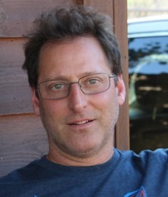

**Gregg Rochman, Treasurer**

Gregg is one of the founding partners of Shine Contracting, where he works as an Urban Developer, Contractor and Project Manager. The Company began its work renovating residential and small commercial buildings in the distressed Limerick neighborhood in Louisville, KY. This began his love for the adaptive reuse of antique buildings.

Working with city of Louisville Economic Development department, Shine Contracting has had notable success in restoring the historic Albert A. Stoll firehouse into what is now The Silver Dollar (seen on multiple “best of” lists for Bourbon Bars in the US) and an 1870s tailor’s shop into the critically acclaimed NuLu restaurant Decca. Shine Contracting has also worked on the historic Marion Taylor building. The Company has won multiple preservation awards for their work from Preservation Louisville. In 2011 Shine Contracting was voted as the Best Contractor in the Leo Magazine. Gregg currently serves on the Board of New Roots as Treasurer and on the Board of The Clifton Center.

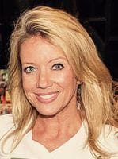

**Lisa Zangari, Board Member and VP of Fund Development**

Lisa is the Director of Learning for the Leadership Louisville Center where she leads the strategy and development of The Leadership Green Room and the newly launched Executive Green Room. Prior to joining the Center, Lisa worked in New York City at ?What If! Innovation Partners as an innovation strategist where she partnered closely with Fortune 500 executives to develop new products, launch new ventures and nurture more innovative corporate cultures. She’s led numerous leadership development programs around the world for companies like AARP, Citibank, Disney, Hasbro, Pfizer, The Hershey Company, and more. Lisa has also partnered with global social good organizations such as Acumen, (RED)™ and Future Generation Foundation.

In addition to her work at Leadership Louisville and serving on the New Roots Board, Lisa is also on the Kentucky Center for the Arts Foundation Board where she focuses on Education and Outreach.

**James Rose, Board Member**

James Rose has expertise in healthcare operations, governance, risk and compliance. He is an expert advisor to the Staff Health Insurance Global Oversight Committee for the World Health Organization, and Chairperson to the Audit and Risk Advisory Committee for Jefferson County Public Schools. His past accomplishments include serving as CFO of Aperture Credentialing, LLC, Chair of the Audit Committee to the World Food Programme, and Director of Navigant. He also serves as an Advisory Committee Member to the Von Allmen School of Accountancy at the University of Kentucky. When he is not doing all of these activities, he does his best to eat all the recommended amounts of fruits and vegetables.

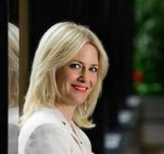

**Gen Howard, Board Member and Co-Chair, Point of Entry Team**

Gen Howard is the Senior Sales Manager for the Louisville Convention & Visitors Bureau. She is responsible for selling Louisville as a premier sports destination to customers across the US. She assists in bringing national sporting events to the city and generates thousands of room nights each year. Howard has been with the Louisville CVB for six years and has been in the hospitality industry for 15 years.Howard graduated from the Ignite Leadership Louisville program this past April and had the pleasure of working with New Roots and Karyn Moskowitz for six months. Howard worked on strengthening government relationships and fundraising for New Roots during the Ignite program, but was so passionate about the work taking place that she joined the board this past May.

Howard attended Western Kentucky University and received a Bachelor of Arts in Corporate Communications & Marketing. Howard grew up in Louisville and is very passionate about the city and everything it has to offer both residents and visitors. Howard and her husband and two boys are vegetarians and enjoy growing their own fruits and vegetables in their urban garden. Howard’s favorite vegetable is kale.



**Lillian Hunt, Board Member**

Lillian moved to Kentucky in July, 2010, when she became the Executive Human Resources Leader for Legal and Leadership Programs for GE Appliances & Lighting in Louisville. In March, 2012, she assumed her current role of Executive HR Leader, Global Finance and Legal for GE Appliances. In January, 2015, she added Diversity to her responsibilities.

Lillian joined GE in 1994 as a Human Resources Manager with GE Mortgage Services in Cherry Hill, NJ and held positions in that business and other GE Capital business units in Houston, Dallas, San Bernardino, CA, Scottsdale, AZ and Danbury, CT.

Prior to joining GE, Lillian held HR positions with PepsiCo and Contel/Verizon.

Lillian has become very active in the Louisville Community. She currently serves on the following Boards: Greater Louisville International Professionals, Business Diversity Network of KY, Women Influencing Louisville, HR Committee for the Center for Women and Families, HR Committee for Metro United Way, New Roots, and the Urban Leadership Alliance Seminar of the Louisville Urban League. She also serves as a Kentucky Colonel for the Commonwealth of Kentucky. She is a member of Delta Sigma Theta, Incorporated and The Links, Incorporated.

She has a B.B.A. in Management from Mississippi State University and an M.B.A. in Finance from the University of Florida.

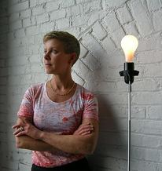

**Patty Marguet, Board Member and VP of Communications**

Design and art direction are at the core of Patty’s 30+ year career. She is a founding partner at local full-service advertising agency, Quantum Communications, along with her husband, Jim Miller, who is Creative Director, and their business partner, Linda Schuster. Daily life for Patty and Jim is the set for creating impactful advertising, branding, marketing and online communications for clients. This naturally spills over into their personal life together which includes setting down and pursuing beauty in their gardens, their food, their environment, their home.Patty’s philanthropic work is focused on assisting organizations with the promotion of healthful eating for everyone, and in sustaining the environment. Besides her position on the board of directors at New Roots, she sits on the board at WCHQ 100.9FM (crescenthillradio.com) where she co-hosts “The Local Life”, a weekly radio program about food and sustainability.

Patty makes all of the food she serves at her table from scratch with the fresh local food from her shares of the Russell Fresh Stop Market. She especially loves to bake bread, which she say’s is the most heart-warming activity in the kitchen.

**Dave Zamiska, Board Member**

Captain Dave works as a flight operations project lead for implementing SMS at UPS Airlines, as well as project lead for line operations safety audit. He spent many years as a commercial pilot, flying for Delta and Midway Airlines. He previously served on the board of directors of Uspiritus, helping children receive psychiatric treatment.

**Colleen Reilly, Board Member and New Roots Harvest Council Advisory Board Liaison**



**Carmen Moreno-Rivera, Board Member**

Carmen Moreno-Rivera is the Air Region Operations Excellence Manager at UPS Airlines and a new New Roots board member. Carmen has a passion for food justice. Welcome, Carmen!

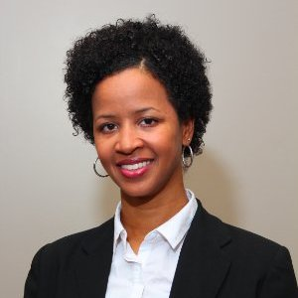

**Jake Miller, Board Member and Co-Chair, Point of Entry**

